Within this context, there has been a group of nations collectively referred to as the M-8 economies of the world, namely China, the United States, India, Germany, Japan, the United Kingdom, France, and South Korea, which have become global leaders in RETI. These countries are the leaders in the number of renewable energy patents in the world as well as in the development of the digital economy. Their different governance systems and financial systems would make them a perfect laboratory to analyze how digital, financial, and governance-related aspects interact to impact the RETI outcomes (fig 1).

The need to ensure that economic recovery and sustainable development are consistent has increased in the post-pandemic era. Digitalization and green innovation have been incorporated into the recovery agendas of global policy frameworks, including the United Nations' Sustainable Development Goals (SDGs) and the outcomes of COP26 and COP27. The pandemic has accelerated the integration of digital technology, offering new opportunities for incorporating technological advancements into climate and energy policy on a larger scale. This is an opportunity that should not be ignored in the case of the M-8 economies, which already possess high-quality digital infrastructures and well-developed innovation capabilities, to create policies that serve the twofold purpose of enhancing economic resilience, driving digital transformation, and promoting environmental sustainability.

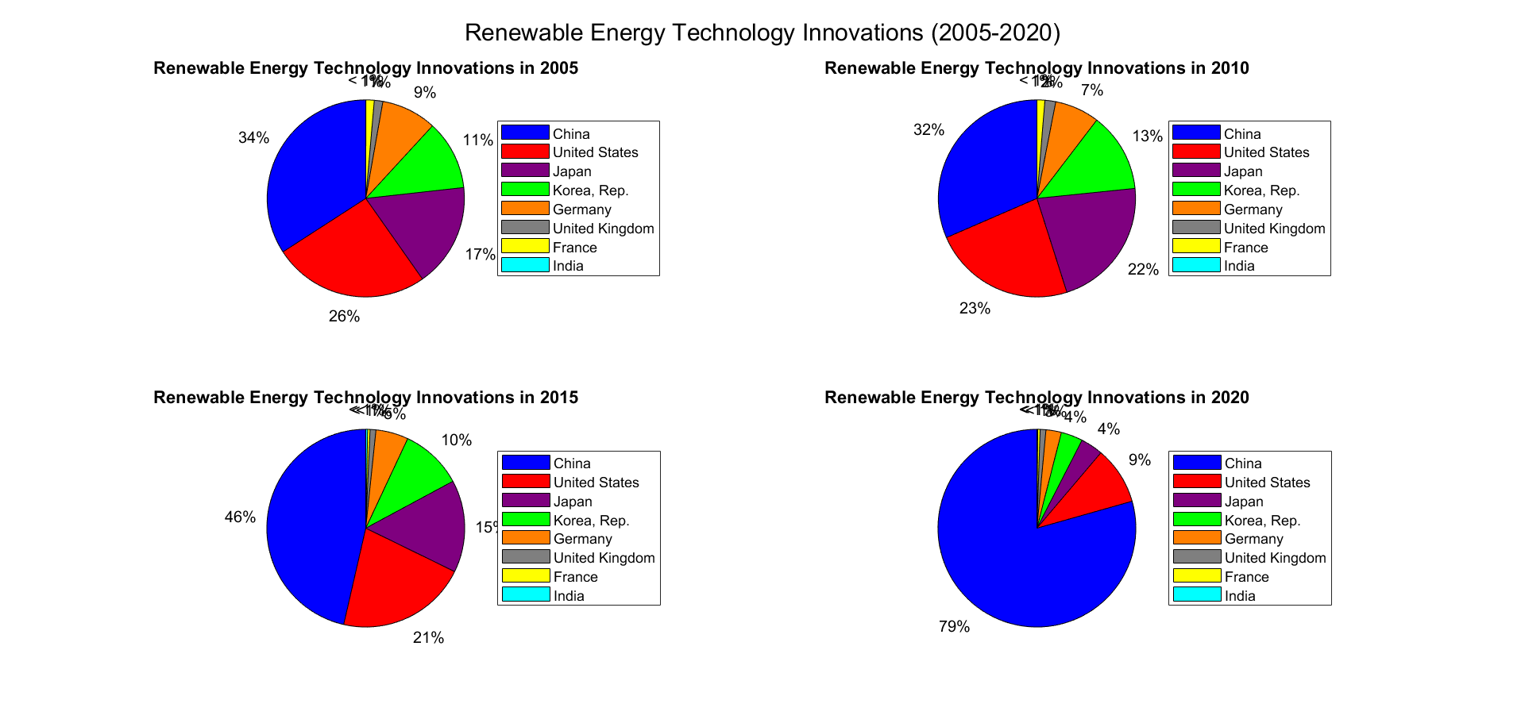

Fig. 1. Passing ratio of [RETI](https://www.sciencedirect.com/topics/earth-and-planetary-sciences/renewable-energy-technology) in M-8 among 2005 & 2020.

The digital economy has become one of the main drivers of the transformation of the energy sector. Energy can be produced, stored, and distributed more efficiently with the help of new digital technologies (artificial intelligence (AI), blockchain, cloud computing, and Internet of Things (IoT)). They facilitate a decentralized renewable framework and consumer control with smart grids and real-time energy analytics (X. Li et al., 2023; Ul-Durar et al., 2024). As of 2020, the worldwide digital economy exceeded USD 32.6 trillion, which is evidence of its game-changing potential in any industry, including energy (Sibt-e-Ali et al., 2023).